HOUSE ACCOUNT NOTES
Service Call # TE45222LI
Radio key button appears on commission but when you go to print preview it doesn’t show.
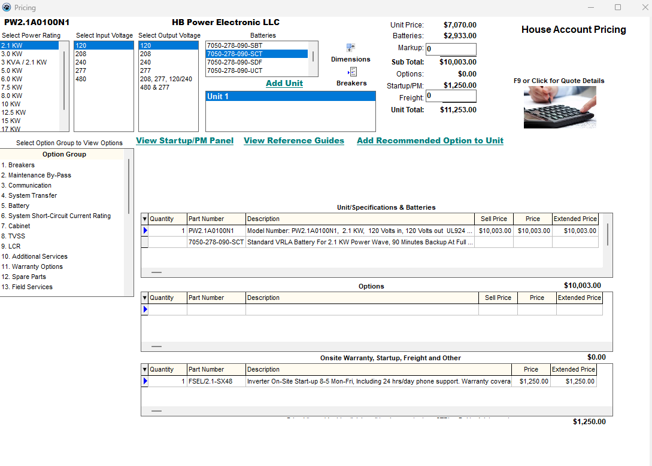

Once I saved record from quote details, and return back to pricing , radio key for commission pops up for some reason
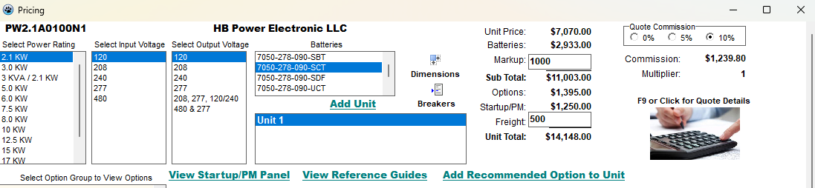
Radio key button should pop up initially when adding options, markups, or freight. If the radio key button for commission was never supposed to be there, remove completely.

Another issue I found is that the Lead Time screen does not exit out when I hit okay. I am able to cancel the lead time but I would have to go back to “go to pricing” and back to quote details to get the correct lead time
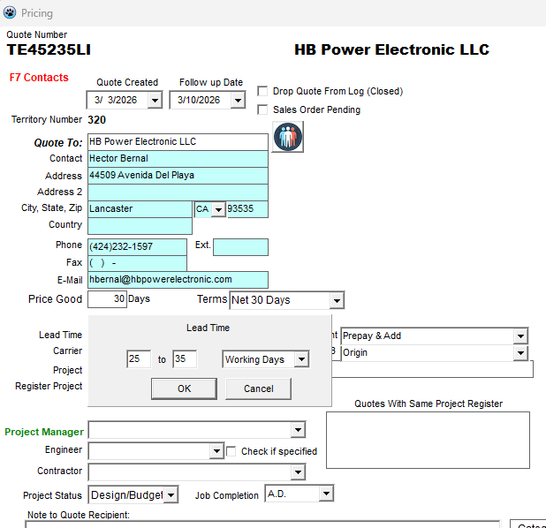

PRIVATE LABEL NOTES
Right after I created a house account quote, I found a bug with markup and sub total
Sub total is not calculating anything.
Options are also not being calculated.
Price and extended price not showing up.
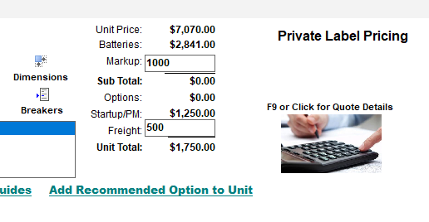
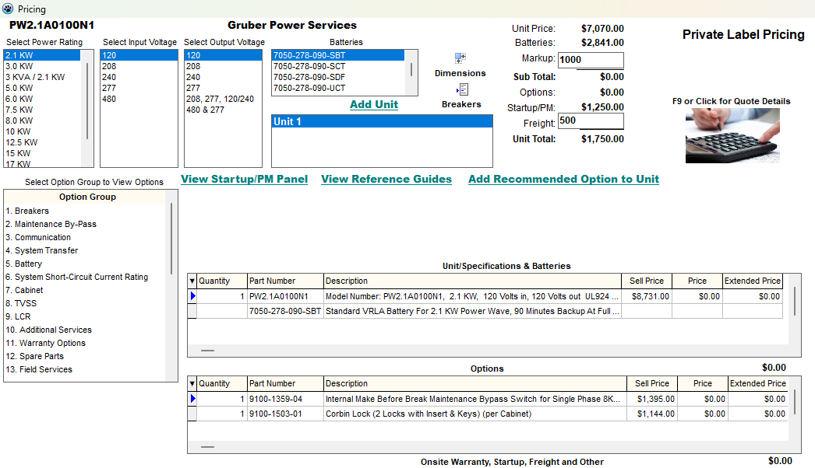
After building the unit and filling out the quote form and saving, I clicked print preview and noticed the cover sheet of the quote is no longer showing the correct pricing/

Line item price is not correct showing zero
Only line item showing up is “On site warranty & startup”
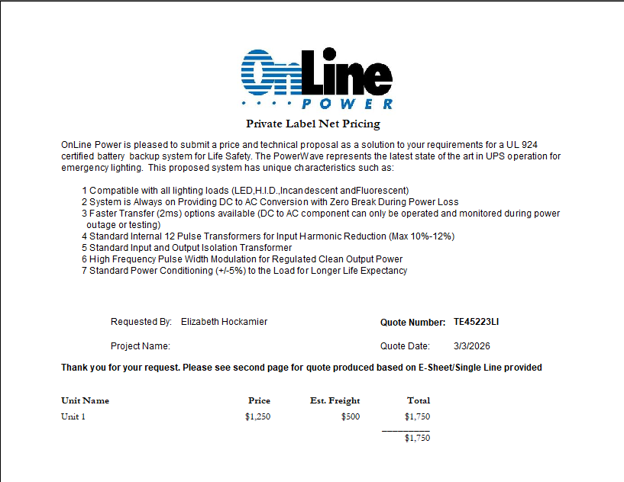
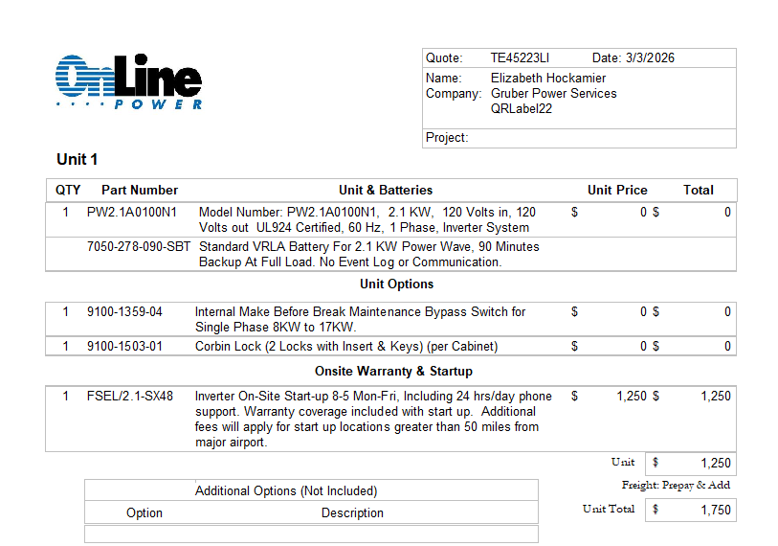

I did the quote once more and ran into the same issue

I did the quote again except I closed the whole test CRM program first and opened it again to essentially start from scratch.
- I created a new private label quote and the sub total and unit total pops up except the two are not adding up correctly.
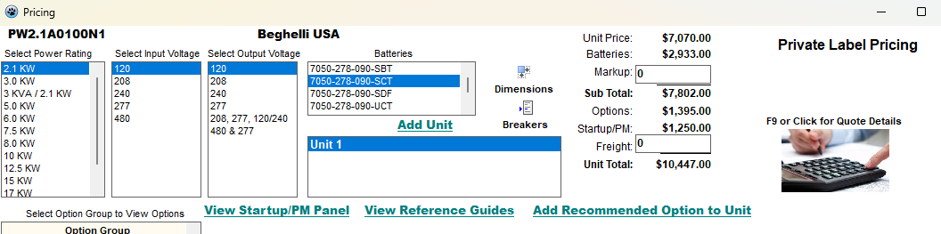

When I added a markup, it does not add up with sub total
- The freight does add up with unit total
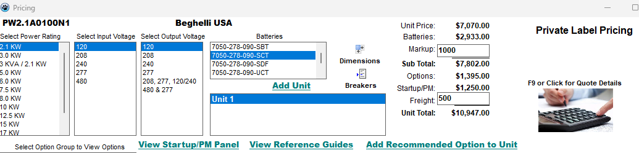

See below, quote does show the same price as the one above.
